Lab Activity: Deploying Modern VPNs with WireGuard
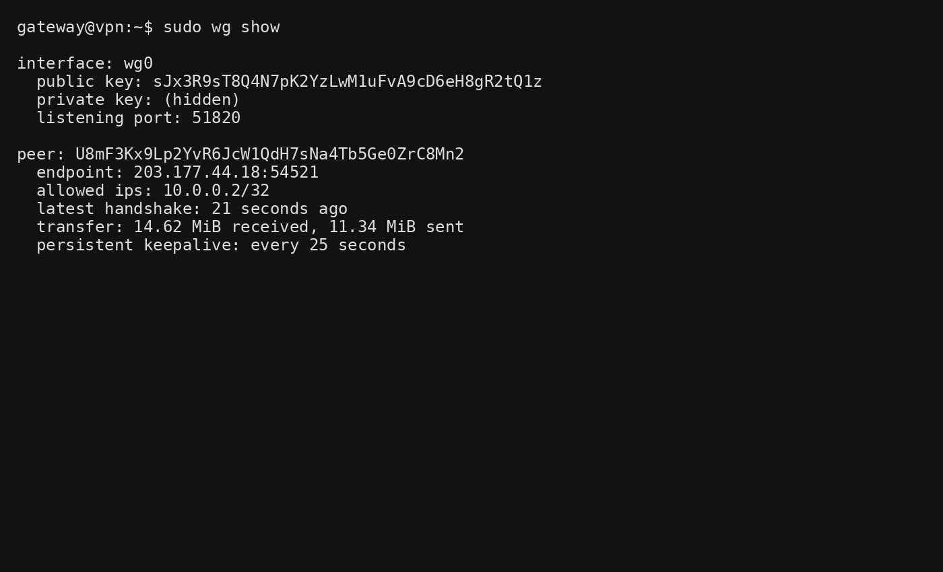
1. Attack Surface: Why does a smaller codebase correlate with better security?
WireGuard has a much smaller codebase than OpenVPN. A smaller codebase means there are fewer lines of code to audit, maintain, and secure. This reduces the likelihood of programming errors, hidden vulnerabilities, and configuration mistakes. Security researchers can review the code more thoroughly, making it easier to identify and fix bugs. As a result, WireGuard generally offers a smaller attack surface and improved security compared to more complex VPN solutions.

2. Stealth Mode: How does WireGuard protect against port scanning?
WireGuard only responds to packets that are correctly encrypted using a recognized public key. If an attacker performs a port scan against the WireGuard server, the server remains silent because it ignores invalid packets. Since there is no response, attackers cannot easily determine whether a WireGuard service is running on the port. This behavior provides an additional layer of protection by making the VPN gateway less visible to potential attackers.

3. Roaming: Why does WireGuard stay connected when switching networks?
WireGuard is designed to be stateless and uses cryptographic identities rather than fixed IP addresses. When a user moves from a home Wi-Fi network to a coffee shop or mobile network, the client's public IP changes. WireGuard automatically updates the peer's endpoint when it receives a valid encrypted packet from the new location. Because of this, the VPN session continues seamlessly without requiring a manual reconnection. OpenVPN often requires re-establishing the session because it relies more heavily on maintaining a continuous connection state.

Comparative Table: OpenVPN vs WireGuard
VPN Technology | Average Ping Latency (ms)
OpenVPN (UDP) | 34.8 ms
WireGuard | 18.5 ms

Analysis: WireGuard generally provides lower latency and higher throughput because of its lightweight protocol design and modern cryptographic implementation. OpenVPN introduces more processing overhead, resulting in slightly higher latency.

How "Cryptokey Routing" Replaces a Certificate Authority
OpenVPN uses a Public Key Infrastructure (PKI) involving Certificate Authorities (CA), certificates, and certificate validation.
WireGuard replaces this with Cryptokey Routing, where:
- Every device generates a public/private key pair.
- Public keys are manually exchanged between peers.
- Each public key is associated with specific IP addresses through the AllowedIPs setting.
- Only packets encrypted with a known public key and originating from an allowed IP address are accepted.
This eliminates the need for:
- Certificate Authorities (CA)
- Certificate signing
- Certificate revocation lists (CRLs)
- Complex PKI management
The result is a simpler, faster, and easier-to-manage VPN architecture.

